Text for social media posts – 2026 Children and Young People’s Patient Experience Survey
Social Media Card 1
If your child has recently been cared for in hospital, you can help shape how services improve.
If you’re invited to take part, you’ll receive the #ChildrenandYoungPeoplesSurvey in the post soon. Your valuable feedback will help us improve the quality of our care and people’s experiences.
Find out more about the survey: [INSERT TRUST PRESS RELEASE LINK FOR CHILDREN AND YOUNG PEOPLE’S SURVEY IF AVAILABLE]
Further information on Section 251: Confidential patient information - Health Research Authority

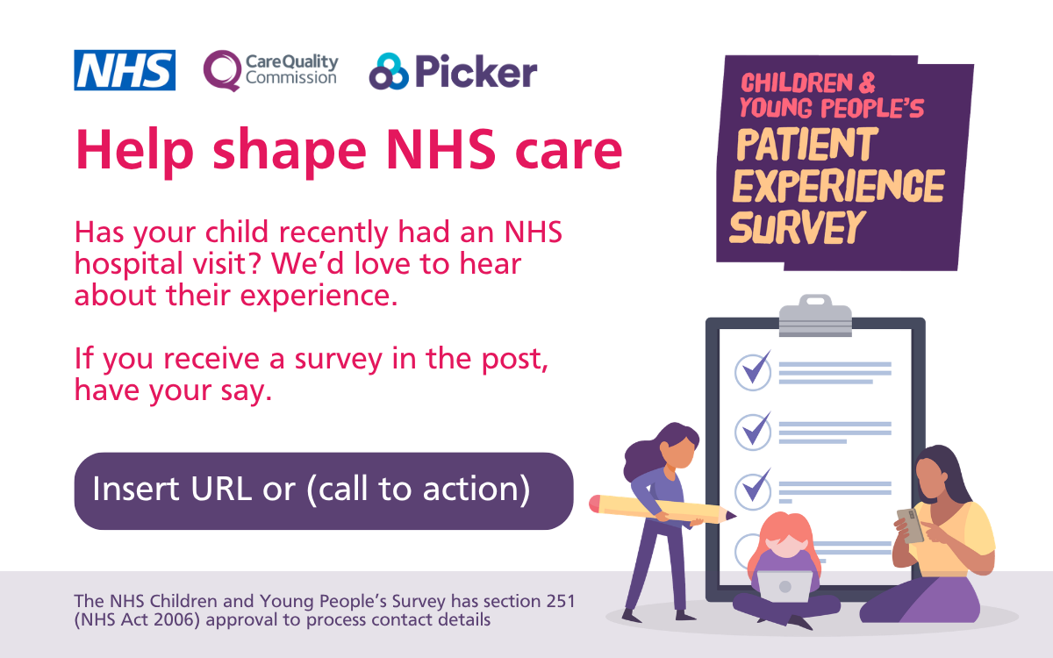
Social media card: Take action

Social Media Card 2
Take the opportunity to make a difference to NHS hospital care for children and young people.
We’d love to hear about your child's experience. The best way for us to improve care is by hearing from people who have recently used our services.
If you’re invited to take part, you’ll receive an invitation in the post and a text message reminder.
Find out more about the survey: [INSERT TRUST PRESS RELEASE LINK FOR CHILDREN AND YOUNG PEOPLE’S SURVEY IF AVAILABLE]
Further information on Section 251: Confidential patient information - Health Research Authority
#ChildrenandYoungPeoplesSurvey

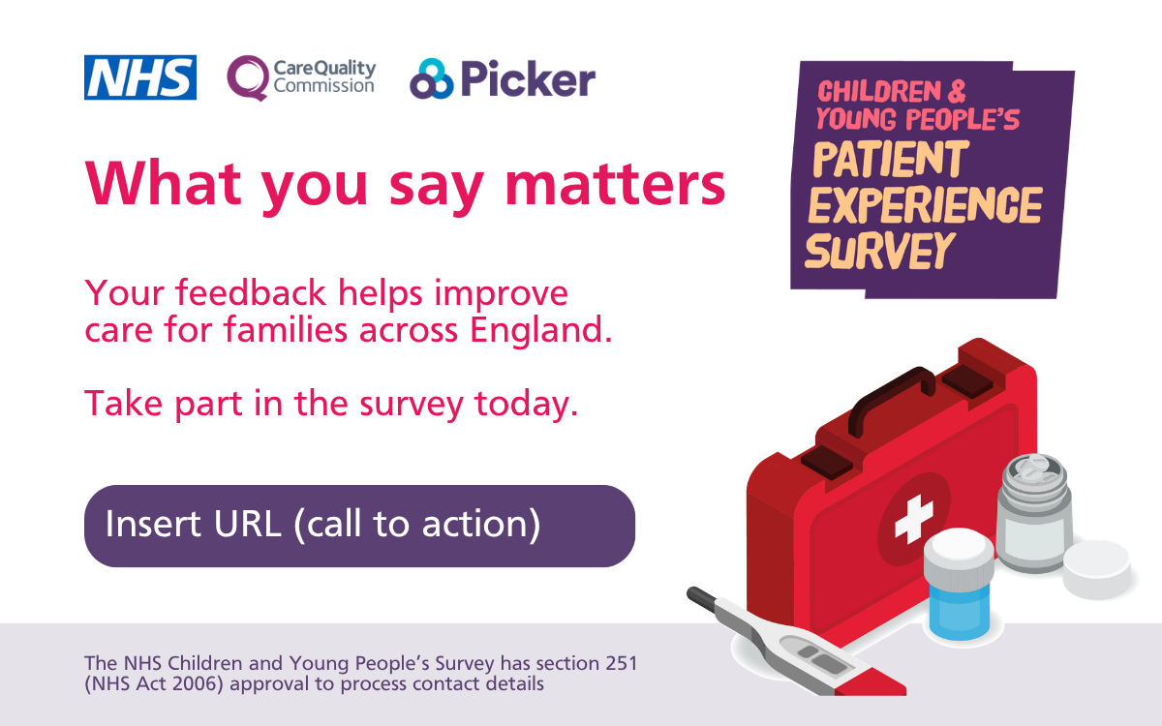
Social media card: Reminder One

Social Media Card 3
Your feedback helps improve hospital care for children and young people. Share your experience and help the NHS make services better.
If you’ve been invited to take part, you should have received the survey in the post. Please complete it as soon as possible - your voice really makes a difference.
Find out more about the survey: [INSERT TRUST PRESS RELEASE LINK FOR CHILDREN AND YOUNG PEOPLE’S SURVEY IF AVAILABLE]
Further information on Section 251: Confidential patient information - Health Research Authority
#ChildrenandYoungPeoplesSurvey

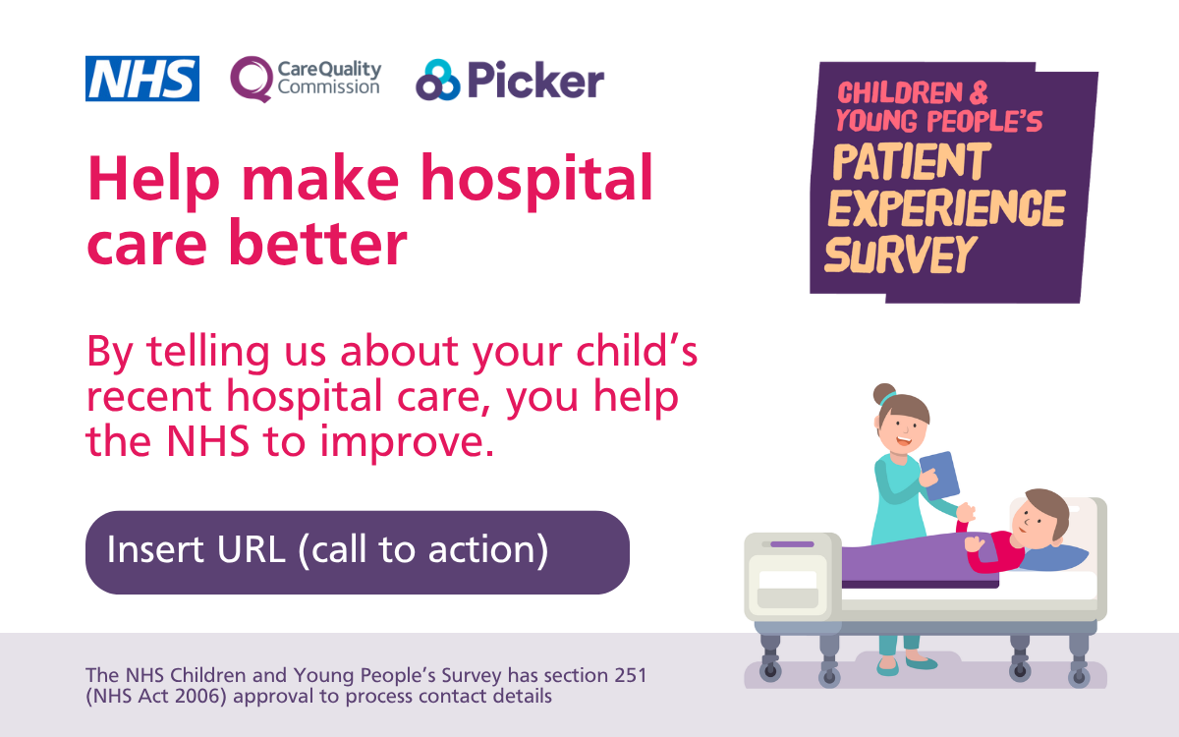
Social media card: Reminder Two

Social Media Card 4
There’s still time to take part. If you’ve received the survey, please complete it before [insert date] and help us improve NHS hospital care for children and young people.
We are listening closely to what you have to say, and your response will help us improve healthcare services for families. Results are published in spring 2027.
Find out more about the survey: [INSERT TRUST PRESS RELEASE LINK FOR CHILDREN AND YOUNG PEOPLE’S SURVEY IF AVAILABLE]
Further information on Section 251: Confidential patient information - Health Research Authority
#ChildrenandYoungPeoplesSurvey

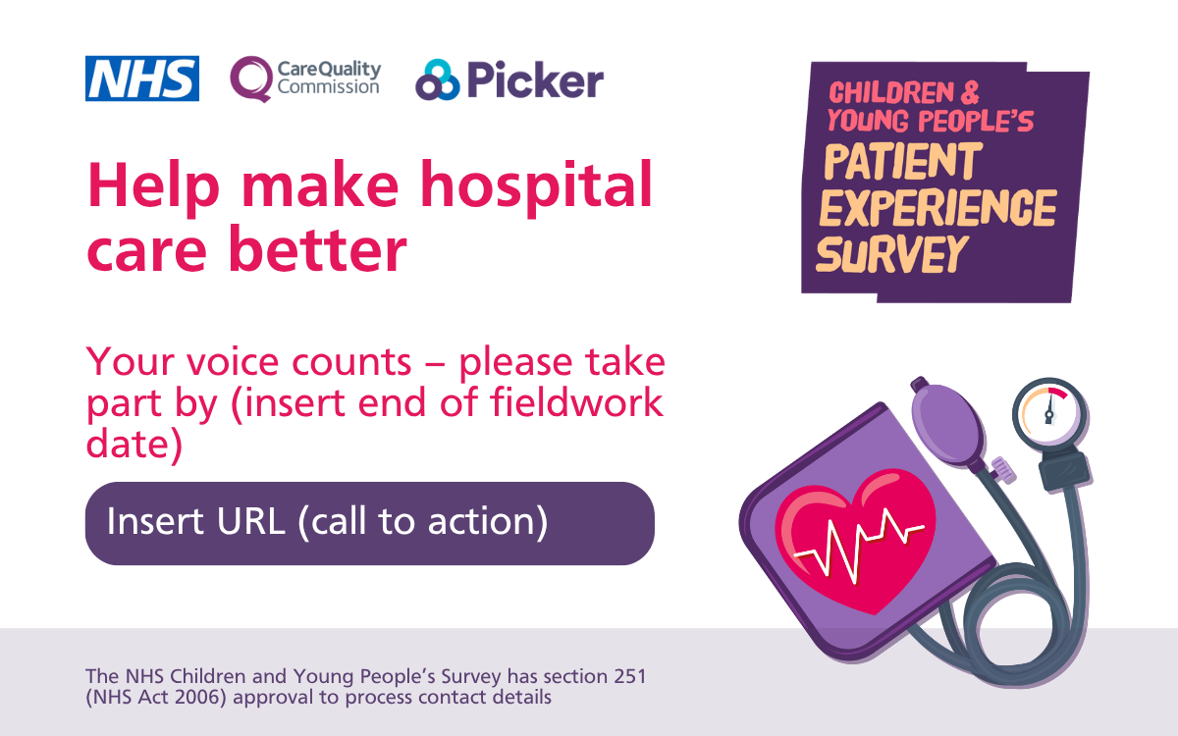
Social media card: Reminder Three

